# Design Documentation – Free choice group

# HomeDork – Interactive Smart House

Revision History

|  |  |
| --- | --- |
| **Name** | **Associated Letter** |
| Fanny Söderlund | A |
| Malek Alabed | B |
| Nishat Jahan | C |
| Suzanne Zomer | D |
| Ismail Eyamba | E |

|  |  |  |  |
| --- | --- | --- | --- |
| **Date** | **Version** | **Description** | **Author** |
| 22/09/2021 | 1.0.0 | Initial discussion of design | A, B, C, D |
| 06/10/2021 | 1.1.0 | Design of mock lab | A, B, C, D |
| 20/10/2021 | 1.2.0 | Additions of figures 2 and 3 | B |
| 21/10/2021 | 1.2.1 | Addition of D4 and complementing figure 4 | A |
| 23/10/2021 | 1.2.2 | Rearranging text, check spelling and details | A, B, C, D, E |
| 27/10/2021 | 1.3.0 | Grammar revised | E |
| 14/11/2021 | 1.3.1 | Changes in document formatting such as versioning, tables, and titles according to group standards. | A |
| 14/11/2021 | 1.3.2 | Addition of D5, table of figures, and designs related to R1 and R8 | A |
| 15/11/2021 | 1.3.3 | Addition of designs related to R2 and R3 | B, C, D |
| 4/12/2021 | 1.4.0 | Addition of designs related to R6, R8 and R9 | A, B, C, D, E |
| 6/12/2021 | 1.4.1 | Addition of diagrams and design to R4 | D |
| 21/12/2021 | 1.5.0 | Addition to D4 and D5: personalised status commands and high contrast | D |
| 21/12/2021 | 1.5.1 | Addition to text in D4, and D5, and addition of Personalised status command use case, and addition of High contrast ratio figure | B |
| 5/1/2022 | 1.5.2 | Format changes, addition of appendix | A, B, C, D, E |

Design item List

|  |  |  |
| --- | --- | --- |
| **Design name** | **Requirements related** | **Priority** |
| D1. Client android app environment | R1, R2, R3 | Essential |
| D2. Client web app environment | R1, R2, R3 | Essential |
| D3. Server/API connection | R2, R4, R5, R6, R8 | Essential |
| D4. Home page designs | R4, R5, R7, R8, R9 | Desirable |
| D5. Settings designs | R1, R2, R3, R6, R10 | Desirable |

Design Item Descriptions

**D1.**

A collection of the designs for the requirements relating to the android client side of the system.

***Mocked environment***

The mocked environment allows the features to be developed encapsulated without outside interaction. The mocked client app is a simple android app that contains the necessary components for the related requirements. The mocked environment is created using Android Studio using mainly Java to integrate easier with the other subgroups. As seen in *figure 1,* the mocked environment aims to be simple with a few components to make it easy for us to develop our features in it.

**D2.**

A collection of the designs for the requirements relating to the web client side of the system.

***Mocked environment***

The mocked environment allows the features to be developed encapsulated without outside interaction. The mocked client app is a simple web app that contains the necessary components for the related requirements. *Figure 2* shows the shell of the mock environment of the web client. *Figure 3* shows the connection of the mocked web client to the sever, whether a mocked API call or the actual system server.

**D3.**

A collection of the designs for the requirements relating to the server of the system. Initially, for testing and developing, the mocked environment will be used, but eventually the implementations will migrate to the actual server/API.

***Mocked environment***

The mocked environment allows the features to be developed and encapsulated without outside interaction. The mocked server allows for testing and implementing of features not yet handled by the current system.

**D4.**

A collection of the designs for the requirements related to the home page, meaning all requirements that are features that the user does not toggle on and off. These features are constant to the system much like the feature to turn on and off different devices.

***R2 – Voice commands***

The voice command feature is in the navigation bar on both clients and allows the user to either navigate through the system or control the devices. *Figures 11-14* shows the diagrams for this feature.

***R4 – Personalized status commands***

This feature is displayed on the home page where the user can set different command buttons that perform different actions set by the user. More is discussed in our requirements document under [R4].

For designing and implementing this feature, *figure 5* have been made. This is not the definite look of the system, but it gives an understanding of the requirement itself and allows us as a group to explain it better to other subgroups and be clear within the group how the feature should function.

**Web implementation:**

The status command feature consists of two JSP pages. The first page displays the buttons each with their custom title and connected devices. The user can click on each of these buttons to activate or deactivate them, controlling devices in their home.

When a new button shall be created, the user shall be redirected to another JSP page where all devices connected to the system, information retrieved from the server, shall be displayed. Here the user can select devices that will be added to this custom status command button, once created the button will be available to see in the first JSP page. *Figure 6* displays the design and *figure 7* the implementation for the features on the web.

**Android implementation:**

The Personalized status command works similarly on the android as it does on the web. What was done inside the Android project to make this possible was add 2 new adapter classes, “Device Adapter” and “Mood Adapter”, and implementing a new model called “Mood”, and we added 4 new activities inside the signup package, and these 4 activities allow a user to add a mood, edit a mood, delete a mood, and keep up with the current moods. and the design aspect of the android was implements very similarly to the design of the web.

***R5 – Scheduled commands***

The scheduled commands feature can be accessed through anywhere in the system. The user can add personal small notes or control the devices on a schedule through here.

**D5.**

A collection of the designs for the requirements related to the settings panel, meaning all requirements that are features that the user can toggle on and off.

***R1 - Haptic vibration***

*Figure 8* shows the class diagram of how the settings pane is related to its xml files for the android client. By using the special “root_preferences.xml” in the xml folder with a PreferencesPane, the changes made in that view will be global to the whole application.

*Figure 9* shows a use case diagram of a user turning on and off the setting for haptic vibration.

*Figure 10* shows a state diagram of the states the application takes when the haptic vibration setting is turned on or off.

***R3 – High contrast***

High contrast is one of a few features that are accessible through the settings pane, both in android and web.

**Android Implementation:**

The implementation for android was made using themes. A theme has been created with custom colors suitable for people with impaired vision, making sure that the contrast ratio maintains a high value throughout the application.

When a new activity is being loaded the program checks for the variable set by the settings pane and applies the correct theme. This is either the standard white theme or high contrast theme. Below see the figure 15 and 16 corresponding to this feature.

**Web Implementation:**

The implementation for the web side of the feature was done very similarly to the android side, a theme is implemented and on that new theme we insert very specific colors that were picked by a website that had the highest high contrast rating(*Figure 18*) and a button was introduced to the top right of the page that when pressed, the theme with the high contrast color is picked.

***R6 – Magnifying zoom***

The zoom feature allows for users with poor eyesight to use the system easier.

***R7 – Bliss expressions***

The bliss expressions are integrated into the feature ***R4 – Personalized status commands*** in every mood button.

***R8 – Game***

The game is a simple JavaScript game that uses mainly the browser’s engine to play. The game saves your local high score locally on the device and your favorite character. *Figures 20* shows the class diagram of this feature and *figure 21* shows the use case diagram.

***R9 – Disco mode***

Disco mode simulates blinking-colored lights inside the client application that can be further developed into actual lightbulbs. *Figures 22-25* shows the diagram related to this feature.

# Appendix

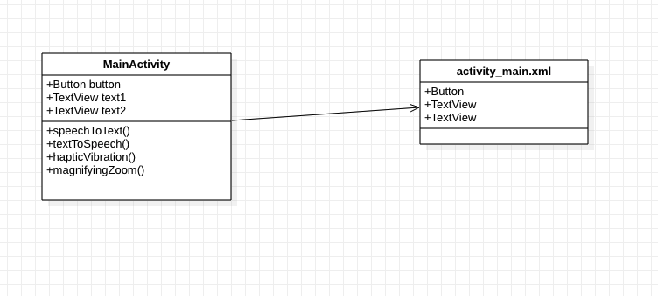

*Figure 1 - Class diagram of mock client android app*

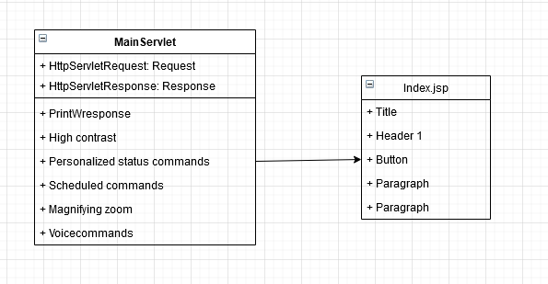

*Figure 2 - Class diagram of mock client android app*

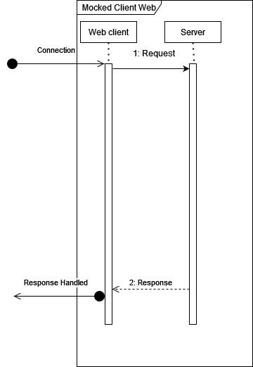

*Figure 3 - Sequence diagram of connection of the mocked web client*

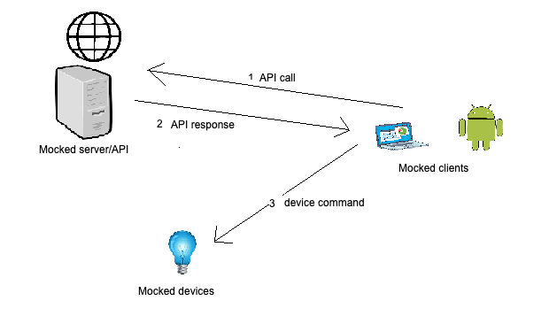

*Figure 4 - General layout of mocked sever/client interaction*

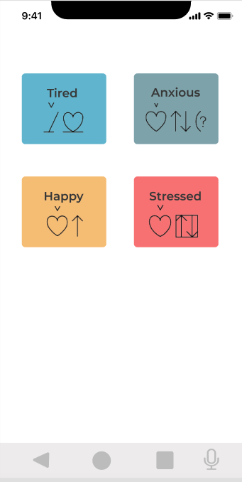 En bild som visar text, iPod, elektronik, skärmbild

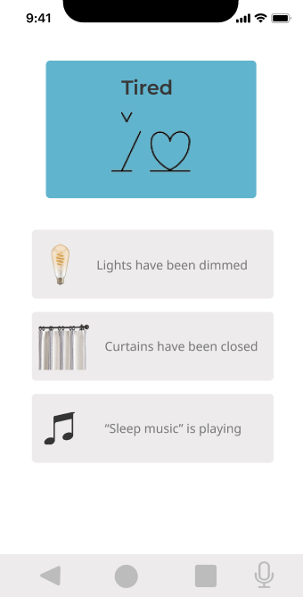

*Figure 5 – Explanatory figures of R4*

*Figure 6 -– Design of status commands on the web*

*Figure 7 – Class diagram of status commands on the web*

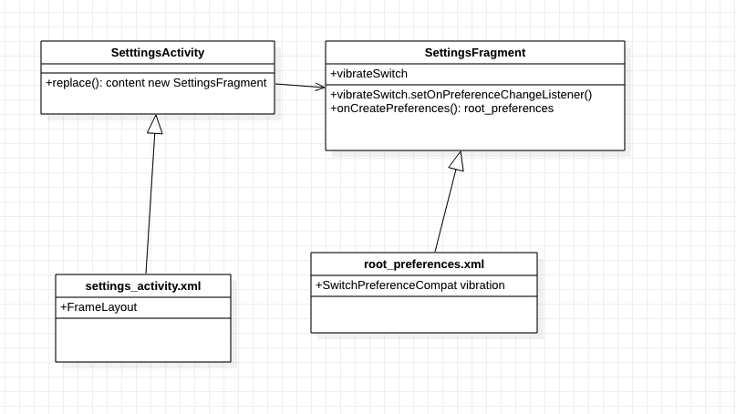

*Figure 8- Class diagram of settings pane with preferences*

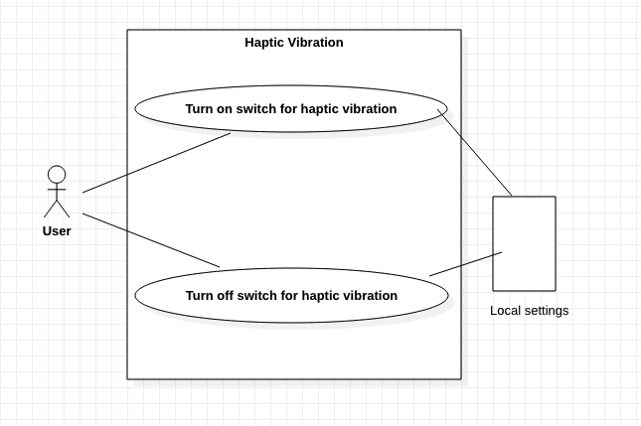

*Figure 9 - Use case diagram of haptic vibration*

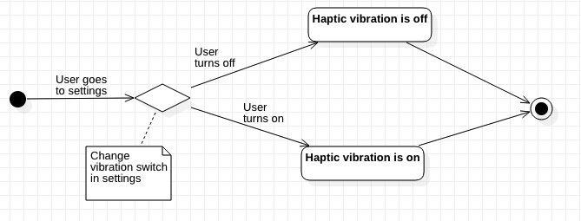

*Figure 10- State diagram of haptic vibration*

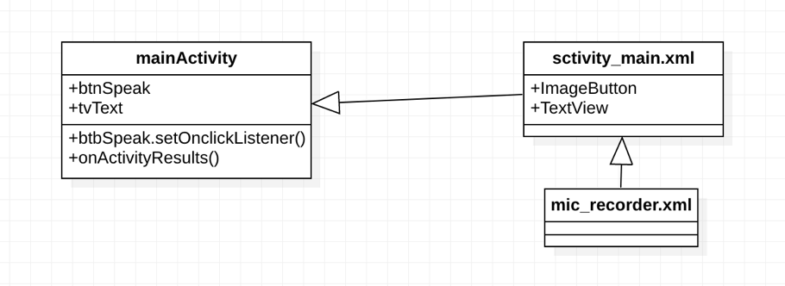

*Figure 11- Class diagram of voice command on Android*

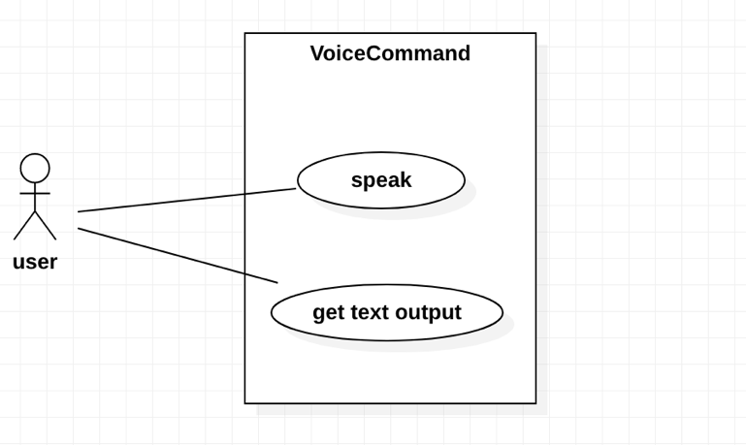

*Figure 12- Use case diagram of voice command on Android*

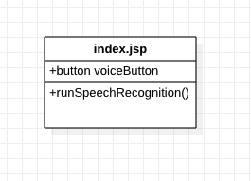

*Figure 13- Class diagram of voice to text on web*

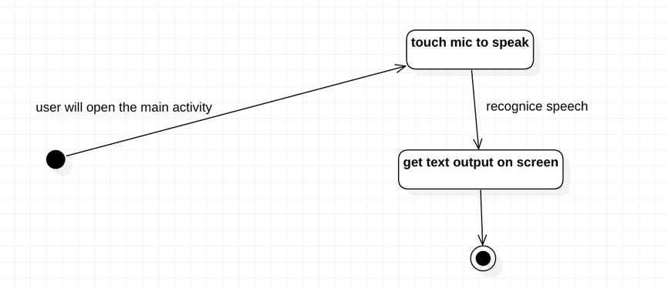

*Figure 14- State diagram of voice command on Android*

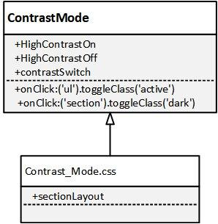

*Figure 15- Class diagram of high contrast on web*

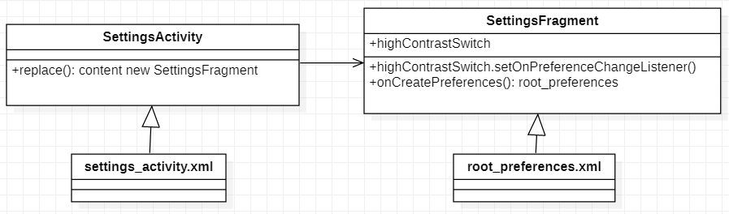

*Figure 16- Class diagram of high contrast on Android*

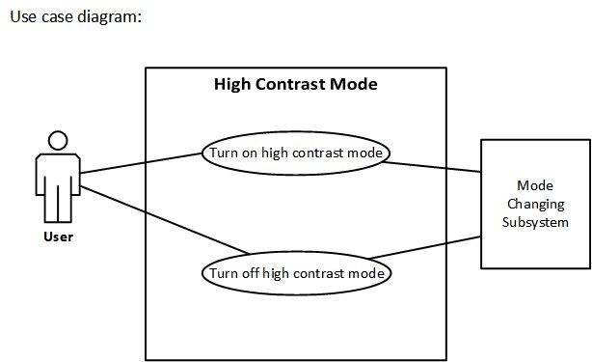

*Figure 17- Use case diagram of high contrast*

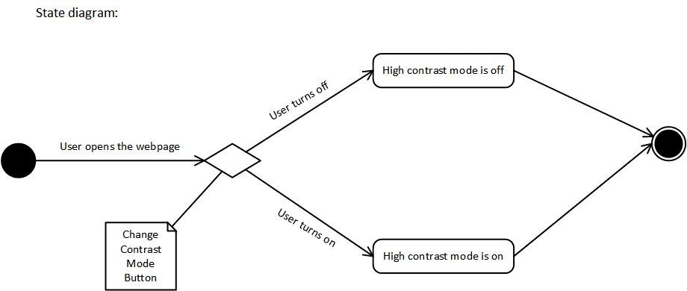

*Figure 18- State diagram of high contrast on web*

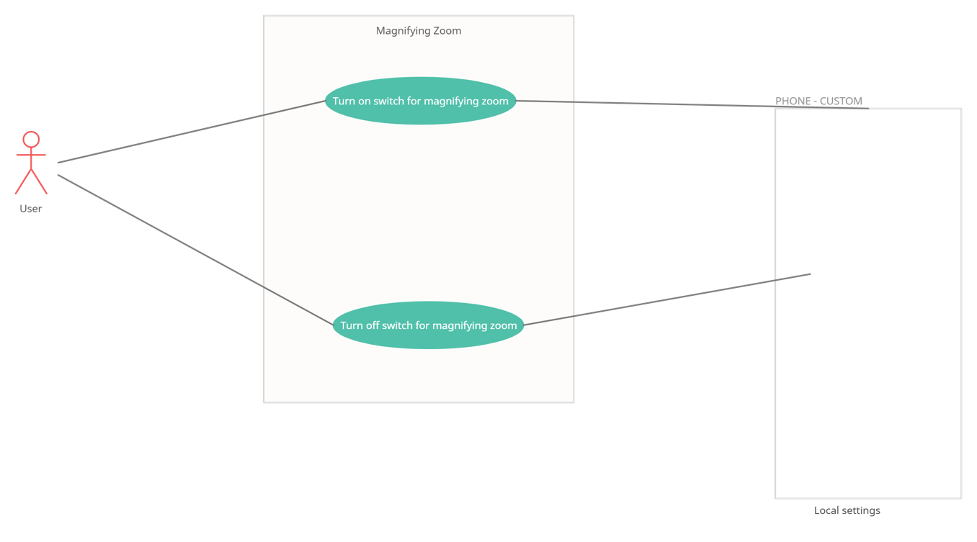

*Figure 19- Use case diagram of magnifying zoom on Android*

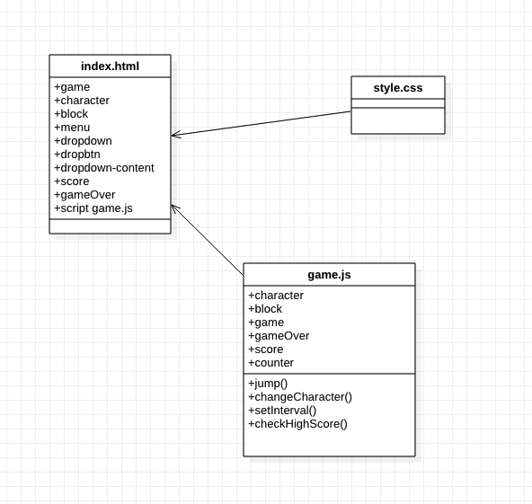

*Figure 20- Class diagram of game*

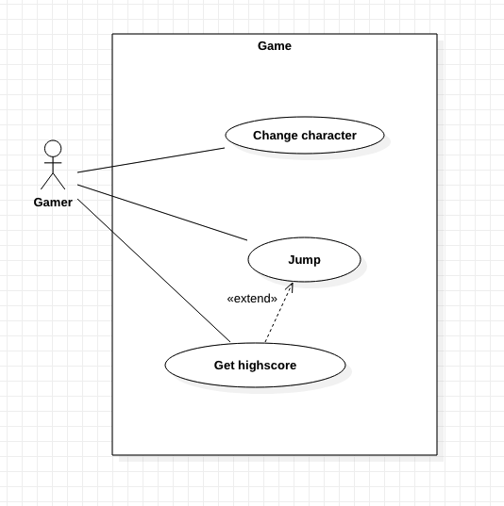

*Figure 21- Use case diagram of game*

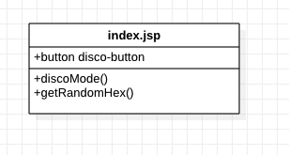

*Figure 22- Class diagram of disco mode on web*

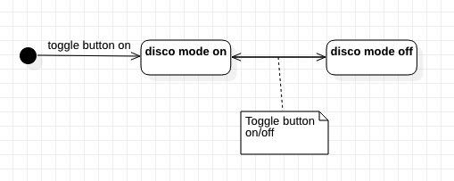

*Figure 23- State diagram of disco mode on web*

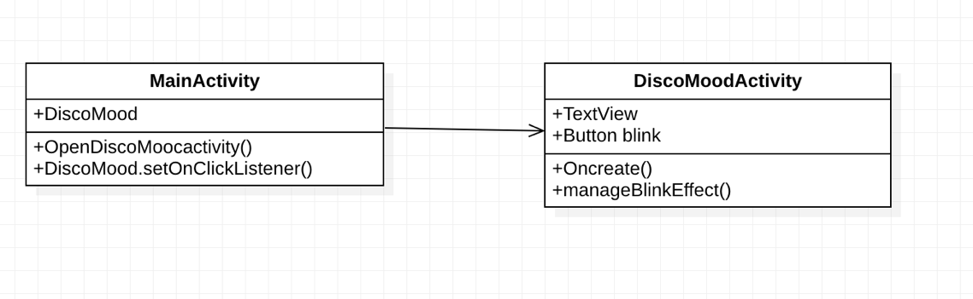

*Figure 24- Class diagram of disco mode on Android*

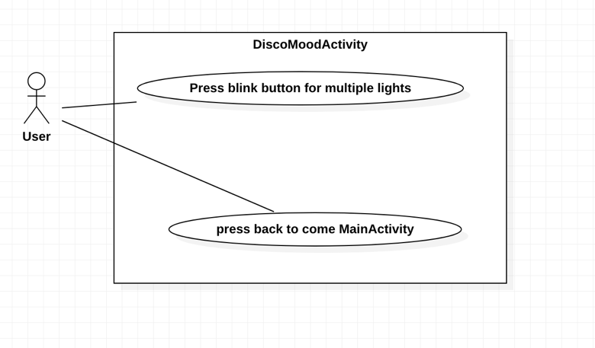

*Figure 25- Use case diagram of disco mode on Andorid*

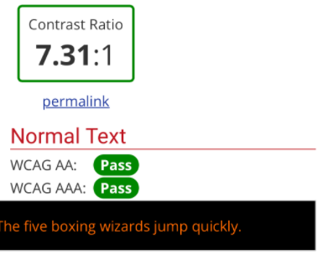

*Figure 26- High contrast ratio*

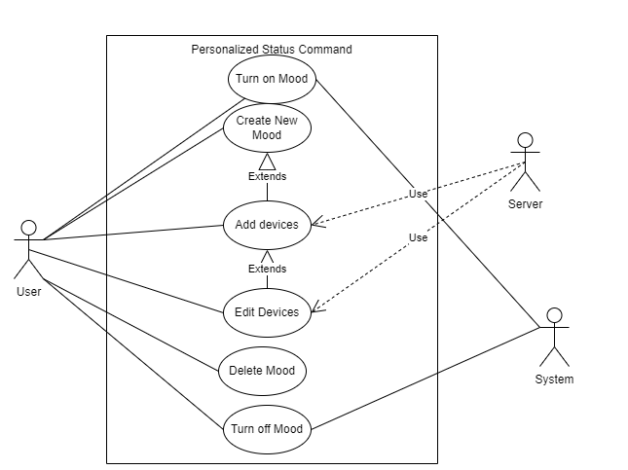

*Figure 27- Personalized Status command Use case*